1. **Video 8: Module Introduction**

* Module content

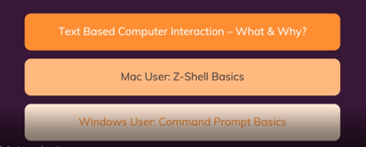

1. **Video 9: The Command Line - What & Why**

* **Text based computer interactions**
  + GUI (Graphical User Interface): e.g. C drive
    - **Advantages:** 
      * User friendly
      * Easy to explore
  + Command Prompt (Text base User interface)
    - **Advantages:** 
      * time saving
      * gives you more option: Start servers, download and install tools, run code, can work with git

1. **Video 19: Windows Command Prompt - The Basics**

* **dir:** lists all items in a directory
* **cd ..** : move one folder level up
* **D:** : changes to the D drive
* **C:** :changes to the C drive

1. **Video 20: Absolute vs Relative Paths**

* **Relative path: starts from current location**
  + cd [Folder name]: accesses a folder
* Absolute path: always starts from the root directory up until the point that you are in

1. **Video 21: Creating & Deleting Files & Folders**

* **mkdir [folder name]** : Creates a new folder
* **cd [folder name]** : navigates to a folder
* **echo [content of file] > [file name] :** creates a file with content
* **del [file name]** :deletes a file
* **rmdir [folder name]**: deletes a folder

1. **Video 22: Copying & Moving Files**

* **copy [file name] [folder name] : Copies a file to a folder**
* **move [file name] [folder name] : moves a file to a folder**
* **move [folder name you are moving] [folder name you are moving to] :** moves one folder into another

1. **Video 23: Windows Command Prompt - Core Commands Overview**

